KLE TECHNOLOGICAL UNIVERSITY, HUBBALLI.
DEPARTMENT OF BACHELOR OF COMPUTER APPLICATIONS
KLE Society’s

A Project SRS document
GiveTrack – Community Donation Ledger with Allocation Tracking
Theme 3 – Ledger and Money Systems
Submitted in partial fulfilment of the requirements for the degree
BACHELOR OF COMPUTER APPLICATIONS
Submitted by:
Ashwini P – 01FE24BCA287
Soumya B – 01FE24BCA293
Swathi – 01FE24BCA304
Veena – 01FE24BCA280
Under the Guidance of
Prof. Pavan Vadavi
Academic Year: 2026–27

1. Introduction
Many community organisations receive donations from different donors and allocate the collected amounts to beneficiaries for various purposes. Maintaining donation and allocation details manually can make it difficult to identify the original source of funds, calculate the amount already allocated and determine the remaining balance.
The proposed project, GiveTrack – Community Donation Ledger with Allocation Tracking, applies a transaction-based ledger approach to community donations. It records donation transactions and links allocation transactions to their original donations. The system derives the allocated total and remaining balance from the stored records and validates allocation requests before accepting them.
The system provides a web interface for authorised users to manage donor and beneficiary details, record donations, record allocations, view allocation status and review donation-related information. It applies foundational concepts from DBMS, OOP, Web Technologies, Data Structures and Programming, and Software Engineering.

1.1 Purpose
The purpose of this project is to develop a web-based system for recording community donations and tracking how donated amounts are allocated. The system maintains donation and allocation records, validates allocation transactions and calculates the remaining balance from accepted records. It aims to reduce manual record-keeping errors and make donation transactions easier to trace and verify.

1.2 Scope
The project focuses on the basic operations required for community donation and allocation management. Its main features include:
- Maintaining donor and beneficiary details.
- Recording donation transactions with date, type, amount and description.
- Recording allocation transactions linked to donations and beneficiaries.
- Validating allocation amounts and related records.
- Calculating total allocated amounts and remaining donation balances.
- Maintaining allocation status and viewing donation-related records.

1.3 Objectives
The main objectives of the project are:
- To maintain donor and beneficiary information systematically.
- To record donation transactions accurately.
- To link each allocation to its original donation and beneficiary.
- To calculate total allocated amounts and remaining balances from stored transactions.
- To prevent the total non-cancelled allocations from exceeding the original donation amount.
- To maintain allocation history for tracking and verification.
- To apply foundational concepts of DBMS, OOP, Web Technologies and Software Engineering.

1.4 Intended Audience
This document is intended for project guides, faculty members, evaluators, developers and students who want to understand the requirements and functionality of GiveTrack. It describes the purpose, scope, features, constraints and technical requirements of the system. It can also be used as a reference during system design, development, testing and maintenance.

1.5 Document Overview
This Software Requirements Specification (SRS) describes the requirements of GiveTrack – Community Donation Ledger with Allocation Tracking. It includes the project introduction, purpose, scope, objectives, functional and non-functional requirements, business rules, system constraints, hardware and software requirements, system diagrams, future enhancements and references.

1.6 Foundational Concepts Used
The project applies the following foundational concepts:
- Database Management Systems (DBMS): Used to store and manage user, donor, beneficiary, donation and allocation records with primary keys, foreign keys and constraints.
- Data Structures and Programming: Used to implement the logic required to calculate allocated totals, determine remaining balances and validate allocation requests.
- Object-Oriented Programming (OOP): Used to organise application operations into Java classes and service components.
- Web Technologies: HTML, CSS and JavaScript are used for the user interface, while Java Servlets handle web requests and responses.
- Software Engineering and SDLC: Used for requirement analysis, design, implementation, integration, testing and maintenance.
- Data Validation and Integrity: Used to ensure that donation and allocation records follow defined rules and maintain valid relationships.

2. Specific Requirements
System requirements describe the functional and operational requirements of GiveTrack. They specify the main features and operations that the system must support for community donation recording and allocation tracking.

2.1 Functional Requirements
Functional requirements describe the operations that the system must perform.
Requirement ID | Functional Requirement | Description
FR-01 | User Login and Logout | The system shall allow registered users to log in and log out using valid credentials.
FR-02 | Manage Donor Details | The system shall allow authorised users to add and view donor details, including name, phone number, email and address.
FR-03 | Manage Beneficiary Details | The system shall allow authorised users to add and view beneficiary details, including name, category, contact and address.
FR-04 | Record Donations | The system shall allow authorised users to record donation details, including donor, donation date, donation type, amount and description.
FR-05 | Record Allocations | The system shall allow authorised users to record allocation details linked to an existing donation and beneficiary.
FR-06 | Maintain Allocation Status | The system shall maintain allocation information, including allocation date, allocated amount, purpose and status.
FR-07 | Calculate Amounts and Balance | The system shall calculate total donation amounts, total allocated amounts and the remaining balance from stored records.
FR-08 | Display Dashboard | The system shall display donation and allocation summaries through the dashboard.
FR-09 | View Stored Records | The system shall allow authorised users to view available donation, beneficiary and allocation records according to their roles.
FR-10 | Manage User Accounts and Roles | The system shall allow the administrator to manage user accounts and assign the supported access roles.
FR-11 | Display Messages | The system shall display appropriate success and error messages during system operations.

2.2 Non-Functional Requirements
Non-Functional Requirement | Description / Target
Performance | The dashboard should load within 5 seconds under defined test conditions with up to 1,000 records. This is a target to be verified through testing.
Usability | Users should be able to access the dashboard and perform common operations using the available navigation and forms.
Reliability | The system should display an appropriate error message when a database operation or user request fails.
Data Accuracy | Dashboard totals and remaining balances must match independently calculated values from the stored records.
Security | Protected pages and APIs must require authentication. Access must be controlled according to assigned user roles.
Compatibility | The application should function correctly in current versions of Google Chrome and Microsoft Edge.
Maintainability | Authentication, database connectivity, application logic and user-interface functions should be organised into separate components.
Portability | The application should run on another compatible computer with the required Java, MySQL and Tomcat configuration.
Data Integrity | Primary keys and foreign keys must maintain valid relationships between users, donors, beneficiaries, donations and allocations.

2.3 Business Rules and System Constraints
- Each user, donor, beneficiary, donation and allocation shall have a unique identifier.
- A donation amount must be a positive value.
- An allocation amount must be a positive value.
- Each allocation shall refer to an existing donation and beneficiary.
- The total non-cancelled allocations for a donation shall not exceed the original donation amount.
- The remaining balance shall be derived from the donation amount minus the applicable allocated amount.
- Allocation purpose is required when recording an allocation.
- Allocation status shall be one of the supported values: PENDING, ALLOCATED, FULFILLED or CANCELLED.
- Only authenticated users shall access protected pages and APIs.
- Access to restricted operations shall depend on the assigned role.
- The system shall use Java, Java Servlets, JDBC, MySQL, HTML, CSS and JavaScript.
- The system shall require a compatible Java environment, MySQL database and servlet container to operate.

3. Hardware and Software Requirements
This section describes the basic hardware and software needed to develop and run the proposed system.

3.1 Hardware Requirements
- Computer or laptop capable of running a web browser, Java development tools and MySQL.
- Minimum 4 GB RAM recommended; 8 GB is preferable for smoother development.
- Sufficient disk space for Java, VS Code, MySQL, Apache Tomcat, Maven and project files.
- A processor capable of running the required development tools and database software.

3.2 Software Requirements
- Operating System: Windows.
- Programming Language: Java.
- Frontend/Web Technologies: HTML, CSS and JavaScript.
- Backend Technology: Java Servlets.
- Database: MySQL.
- Database Connectivity: JDBC.
- Servlet Container: Apache Tomcat 9.
- Build Tool: Apache Maven.
- Database Tool: MySQL Workbench.
- Development Tool: Visual Studio Code (VS Code).
- Web Browser: Google Chrome or Microsoft Edge.

3.3 Purpose of the Technologies
- Java is used to implement application logic and service operations.
- Java Servlets handle web requests and responses between the browser and backend.
- HTML, CSS and JavaScript are used to develop web pages and user interactions.
- MySQL is used to store user, donor, beneficiary, donation and allocation records.
- JDBC is used to connect the Java application with the MySQL database.
- Apache Tomcat is used to run the servlet-based web application.
- Maven is used to manage project dependencies and build the application.
- VS Code is used for writing and managing project code.
- MySQL Workbench is used to create, inspect and manage the database.

4. System Architecture
GiveTrack follows a layered web application structure. The browser-based interface sends requests to the Java Servlet layer. The servlet and service components validate requests, apply role and allocation rules, and use JDBC to access the MySQL database.
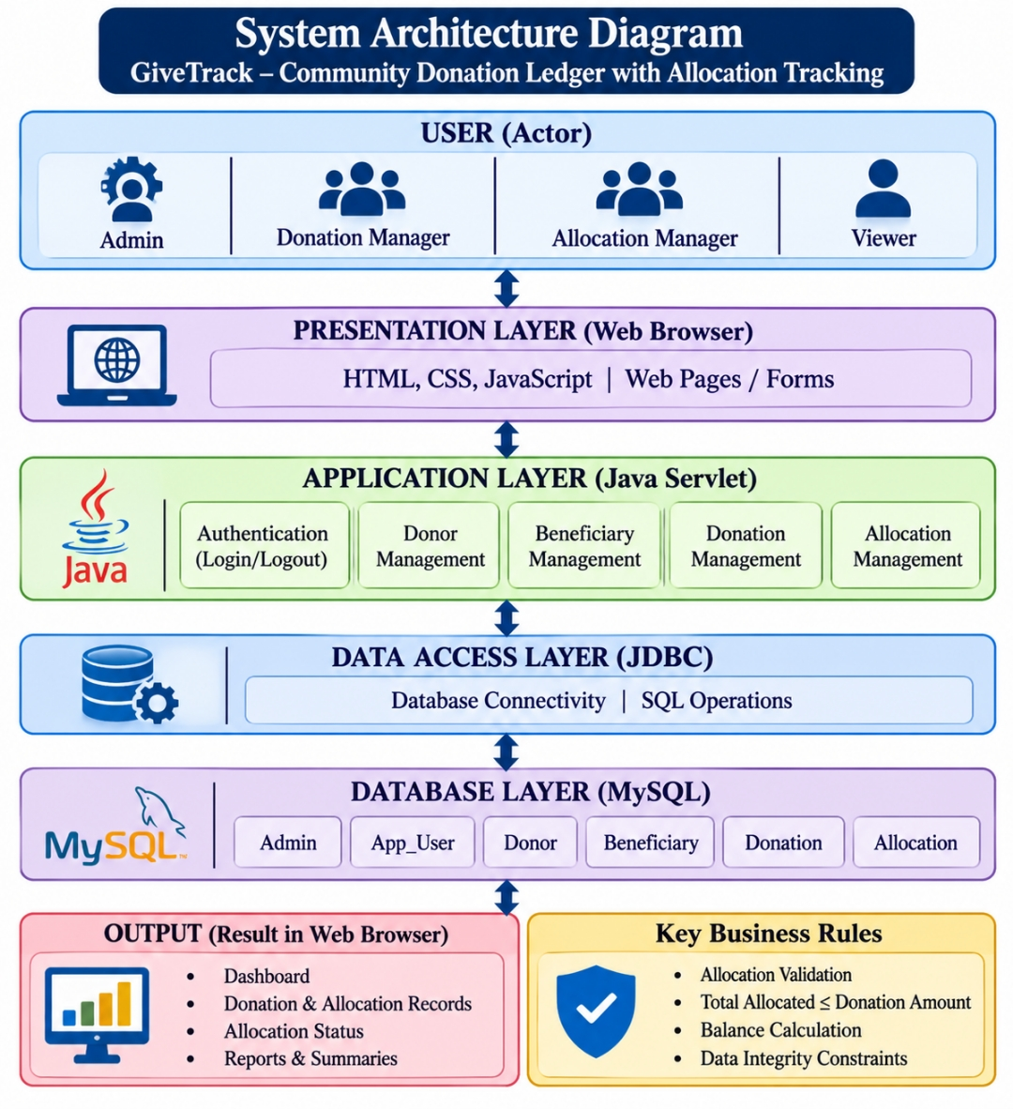

5. ER Diagram
The Entity Relationship Diagram represents the database structure of GiveTrack. It shows the relationships between administrators, donors, donations, allocations and beneficiaries.
The ADMIN entity stores administrator details. DONOR stores donor information, while BENEFICIARY stores beneficiary information. DONATION records the amount received from a donor and the administrator associated with the record. ALLOCATION records the amount allocated from a donation to a beneficiary, along with the allocation date, purpose and status. The APP_USER table stores login accounts and roles used for authentication.
Primary keys uniquely identify records, while foreign keys maintain relationships between the tables. One donor can have multiple donations, one donation can have multiple allocations, and a beneficiary can receive multiple allocations.
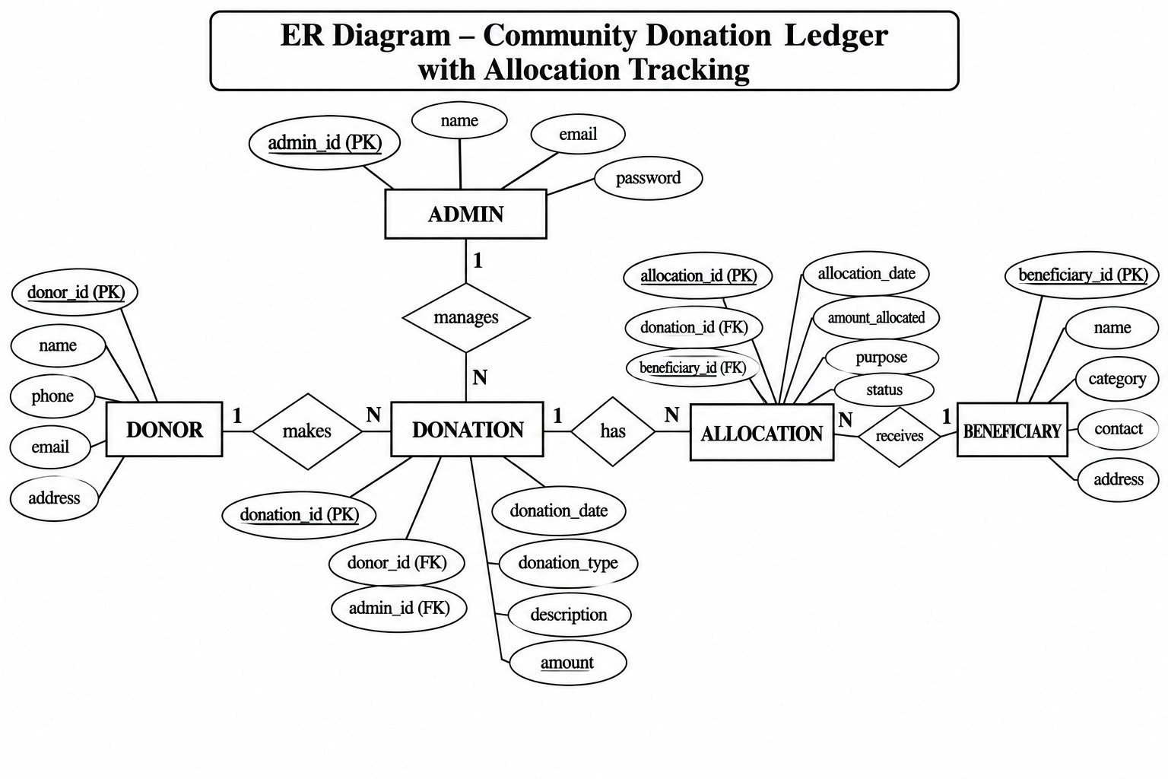

6. UML Diagrams
Unified Modeling Language (UML) diagrams are used to represent the structure and behaviour of the proposed system.
The Activity Diagram shows the allocation process. The Use-case Diagram shows the interactions of the four application roles. The Sequence Diagram represents the donation and allocation interaction. The Class Diagram represents the main application and service classes. The State Diagram represents the flow of the application from login to logout.

6.1 Activity Diagram
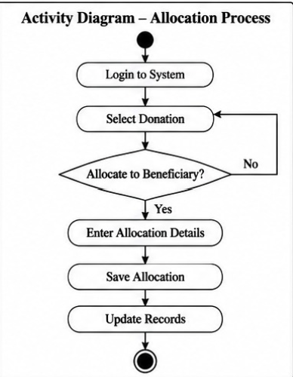

6.2 Use-case Diagram
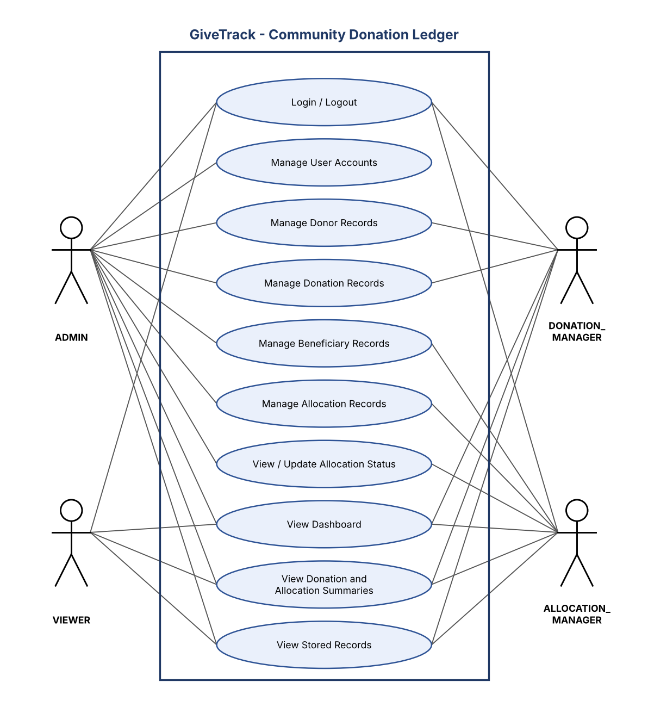

6.3 Sequence Diagram
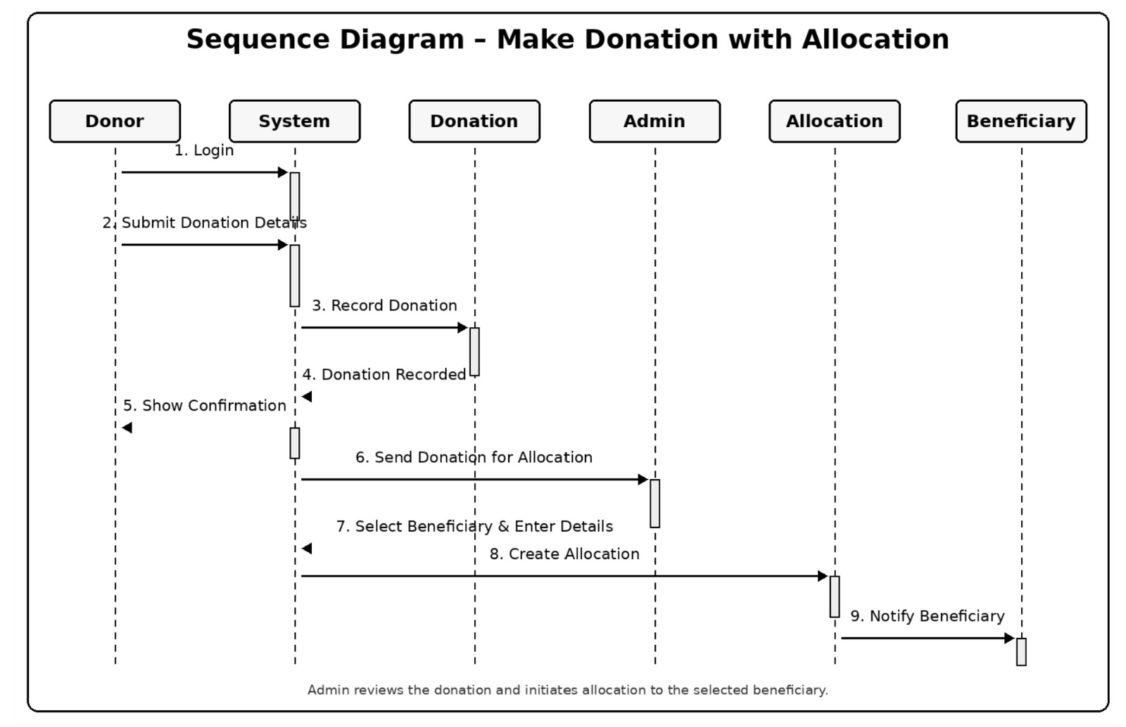

6.4 Class Diagram
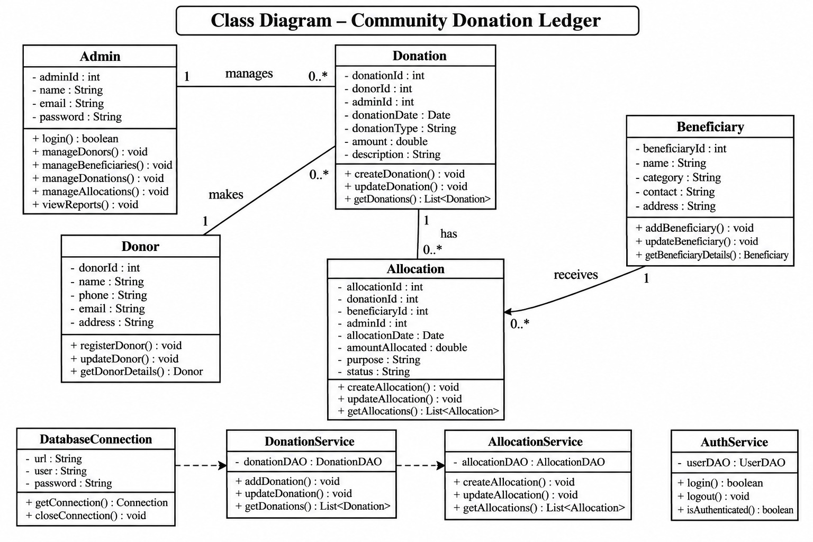

6.5 State Diagram
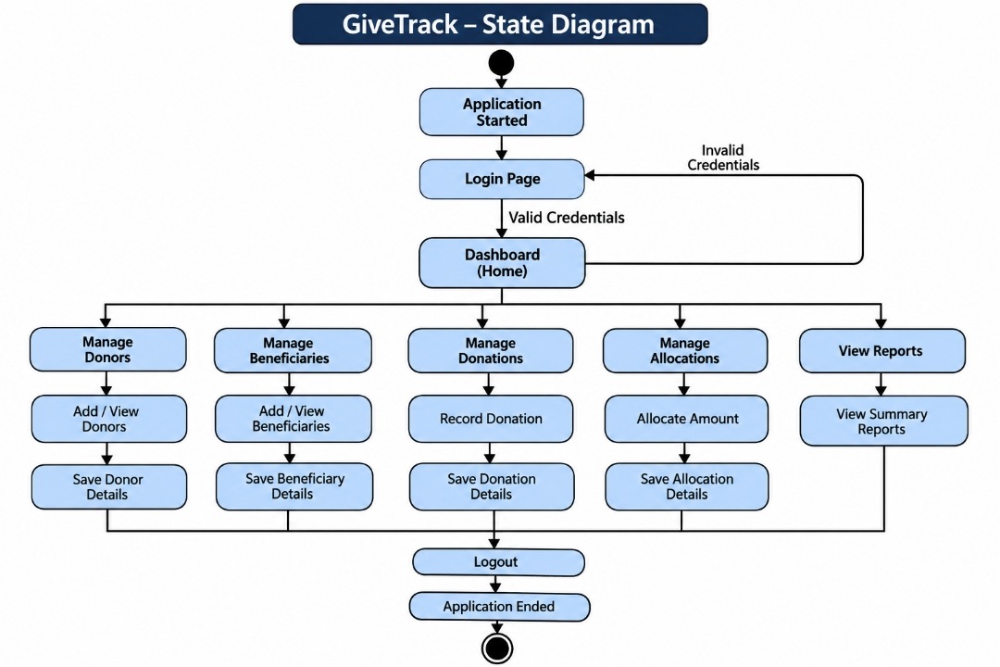

7. Data Flow Diagrams
Data Flow Diagrams represent how information moves through the system.
The Level 0 DFD provides an overall view of GiveTrack as a single process. The users send login details and donation, allocation and report requests to the system, and the system stores and retrieves records from the MySQL database and returns dashboards, reports and messages.
The Level 1 DFD divides the system into major processes: managing users, managing donors and beneficiaries, recording donations and allocations, and generating reports and the dashboard.
The Level 2 DFD provides a more detailed view of recording donations and allocations. It explains validation of the input, processing of the donation or allocation, and updating the database while calculating the balance.

7.1 Level 0 DFD
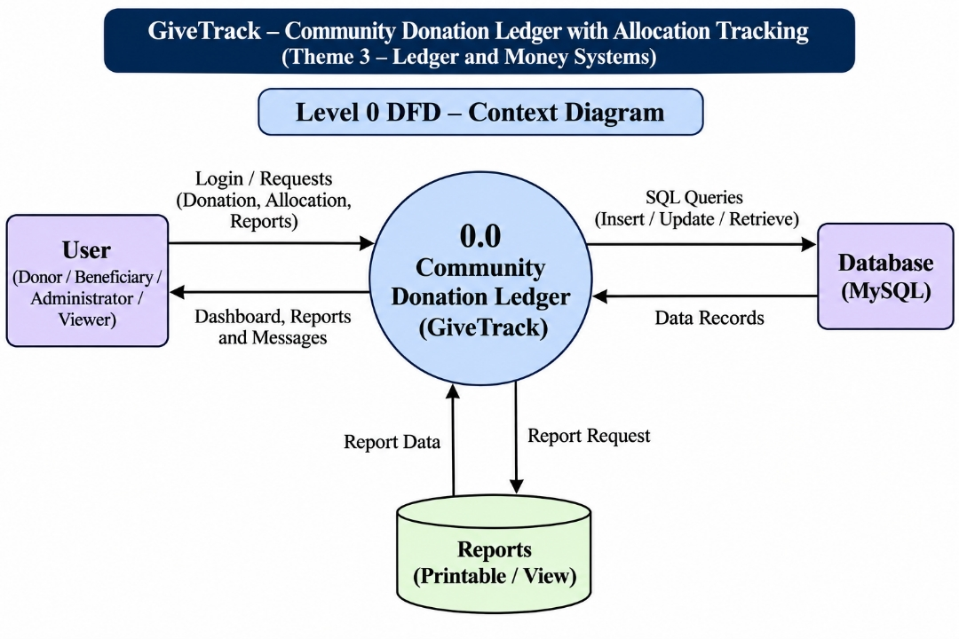

7.2 Level 1 DFD
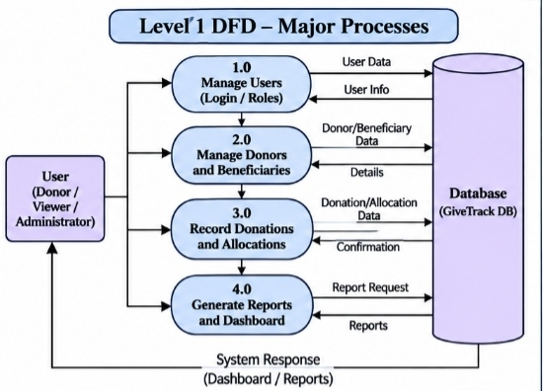

7.3 Level 2 DFD
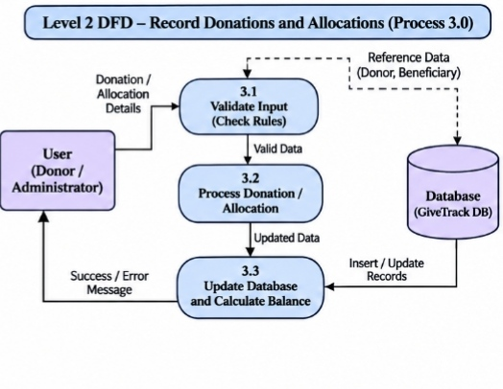

8. Future Enhancement
The current project focuses on maintaining donor, beneficiary, donation and allocation records, validating allocations and calculating balances. The system can be improved in the future by adding the following features:
- Online Payment Integration: A payment gateway can be added to allow donors to contribute directly through the application.
- Donor Login and Dashboard: Donors can be allowed to create accounts and view their own donation history.
- Beneficiary Portal: Beneficiaries can be provided with a separate portal to view permitted allocation information.
- Donation Receipt Generation: The system can generate downloadable receipts for recorded donations.
- Advanced Reports: Detailed donation-wise, beneficiary-wise and date-wise financial reports can be added.
- Notifications: Email or SMS notifications can be added for donation confirmations and allocation updates.
- Audit History: A detailed audit history can record the user and time associated with important changes.
- Mobile-Friendly Interface: The interface can be improved for convenient use on mobile phones and tablets.
These features are not included in the current project unless separately implemented. They may be added in future versions of the system.

9. Conclusion
GiveTrack – Community Donation Ledger with Allocation Tracking aims to provide a structured method for recording, validating and maintaining community donation and allocation transactions. The system links allocation records to their original donations and derives allocated totals and remaining balances from stored records instead of relying on manually entered balance values.
The project focuses on preventing allocations from exceeding the original donation amount, maintaining traceable records and providing authorised users with donation and allocation information. It applies foundational concepts of DBMS, Data Structures and Programming, OOP, Web Technologies, and Software Engineering and SDLC.
The proposed system is developed using Java, Java Servlets, JDBC and MySQL, with testing and validation used to check the correctness and consistency of donation and allocation operations.

10. References
- Oracle. Java Documentation. https://docs.oracle.com/en/java/
- Apache Tomcat. Tomcat 9 Documentation. https://tomcat.apache.org/tomcat-9.0-doc/
- Oracle. MySQL Reference Manual. https://dev.mysql.com/doc/
- Oracle. JDBC Documentation. https://docs.oracle.com/javase/tutorial/jdbc/
- Apache Maven. Maven Documentation. https://maven.apache.org/guides/
- Microsoft. Visual Studio Code Documentation. https://code.visualstudio.com/docs
- Course materials for Database Management Systems (DBMS), Data Structures and Algorithms, Web Technologies, Object-Oriented Programming, Software Engineering and Software Testing.
- BCA Mini Project Framework and Gate Assessment Guidelines provided by the department.
- GiveTrack – Community Donation Ledger with Allocation Tracking, Gate 1 Evidence Document.

